**Weka Assignment by :**

**K.AKSHAY KUMAR**

**192110006**

**Dataset Name: Vote**

Source of the dataset : https://github.com/bjpublic/weka/blob/main/data/vote.arff

Dataset description The data set contains 3 classes of 435 instances each where each class refers to a type of iris plant.

No of attributes: 17

No of instances: 435

**The inputs and output are:**

|  |  |  |
| --- | --- | --- |
| **Data Set** | **Input** | **Output** |
| IRIS | 1.Handicaped-Infants  2.Water project cost sharing  3.Adoption of the budget resolution  4.Physician fee freeze  5.El Salvador Aid  6.Religious groups in school  7.Anti satellite contras  8. Aid to Nicaraguan contras  9. Mx missiles  10. Class | Handicaped-Infants: class  Water project cost sharing: class  Adoption of the budget resolution: class  Physician fee freeze: class  .El Salvador Aid : class  Religious groups in school : class  Anti satellite contras : class  Aid to Nicaraguan contras : class  Mx missiles : class |

**SEARCH FOR BEST MODEL**

**3. Data Preparation**

Removal of null data types, empty instances and false attribute.

**4. Selecting an Algorithm**

|  |  |  |
| --- | --- | --- |
| **Algorithm** | **Result from Weka** | |
| **Correctly Classified Instances** | **Mean Absolute Error** |
| **Weka Classifiers Bayes** | | |
| Bayes Net | 392 | 0.1005 |
| Naïve Bayes | 392 | 0.0995 |
| Naïve Bayes Updateable | 392 | 0.0995 |
| **Weka Classifiers Functions** | | |
| Logistic | 418 | 0.0496 |
| SMO | 418 | 0.0391 |
| SimpleLogistic | 422 | 0.0675 |
| **Weka Classifiers Lazy** | | |
| IBk | 402 | 0.073 |
| LWL | 416 | 0.0712 |
| **Weka Classifiers Meta** | | |
| Bagging | 416 | 0.0698 |
| Ada Boost M1 | 415 | 0.0564 |
| **Weka Classifier Trees** | | |
| J48 | 419 | 0.0611 |

**Data Preprocessing:**

|  |  |
| --- | --- |
| **Attribute Evaluator** | Classifier Subset Eval (Classifier: meta.Bagging with training parameter: classifiers = J48 and the others in their default) |
| **Search Method** | BestFirst (Direction: Forward) |
| **Evaluation Mode** | 10-fold cross-validation (Folds = 10, Seed =1) |

**6.TREE PRODUCED:**

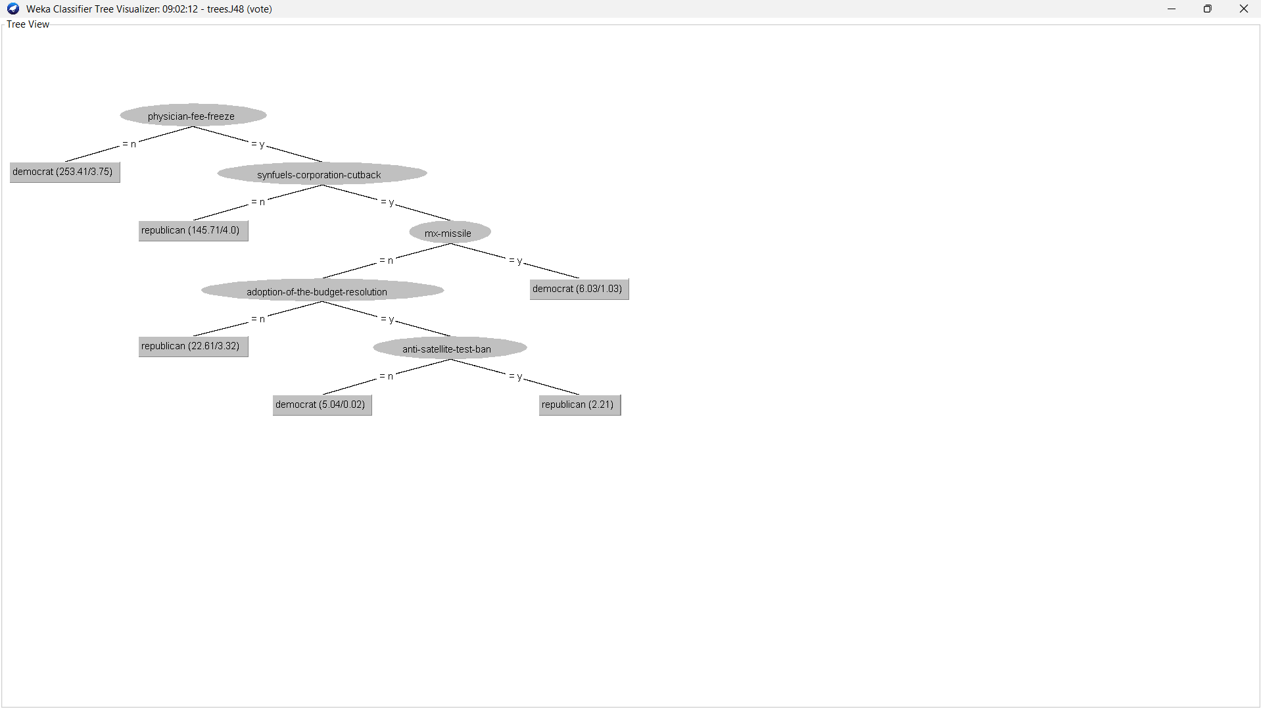

SCREENSHOT :

